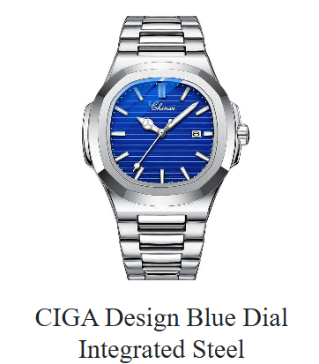

**Product Name:** CIGA Design U Series Blue Planet – Stainless Steel

**Description:**  
The CIGA Design U Series Blue Planet is an award-winning mechanical watch that reimagines time-telling through a rotating 3D globe dial. Encased in stainless steel, it features a unique compass rose indicator and a patented asynchronous movement, offering both artistic appeal and horological innovation

**⚙️ Specifications:**

* **Movement:** Automatic mechanical (CIGA Design self-designed movement)
* **Power Reserve:** Approximately 40 hours
* **Frequency:** 28,800 vibrations per hour (vph)
* **Jewels:** 30
* **Case Material:** Stainless steel
* **Case Diameter:** 46 mm
* **Case Thickness:** 15 mm
* **Crystal:** Double-domed sapphire crystal (front and back)
* **Dial:** 3D micro-carved globe with compass rose time indicator
* **Strap Material:** Blue fluorine rubber
* **Strap Width:** 22 mm
* **Clasp:** Stainless steel butterfly clasp with push-button
* **Water Resistance:** 30 meters (3 ATM)
* **Weight:** Approximately 95.5 grams (including strap)
* **Warranty:** 2 years

**Price:**

$899 USD